
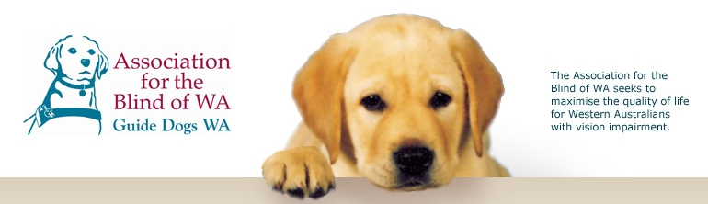

Module 2 – Disability in Society

This module links with Society and Environment Outcomes, based on interaction in society and the role of people with disabilities, their capability in society, and how to confidently and effectively interact with blind and vision impaired people.

The following information has been drawn from the Curriculum Framework document and associated Curriculum Guidelines to help teachers place the module in context.

SOCIETY AND ENVIRONMENT
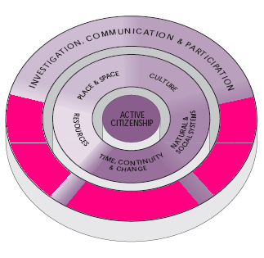

INVESTIGATION, COMMUNICATION AND PARTICIPATION

….Students investigate the ways in which people interact with each other and with their environments in order to make informed decisions and implement relevant social action…..

…..Students investigate aspects of time, place, culture, resources and systems to understand and act on important issues in their social and environmental world. In these investigations, they use skills of critical inquiry and ethical decision making in order to become better-informed, active citizens….

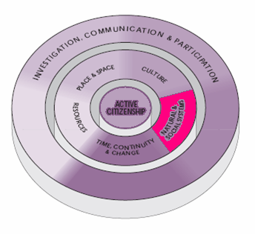

NATURAL AND SOCIAL SYSTEMS
…..Students understand that systems provide order to the dynamic natural and social relationships occurring in the world….

…..Students recognise that a number of social systems that exist vary both in their function (e.g. political, legal, and economic) and scale (e.g. family unit, national, community, global)…
….Students understand that the creation of rules and laws is necessary to ensure civic rights and associated responsibilities. They further understand that where rights are infringed and responsibilities are not met, consequences are evident....

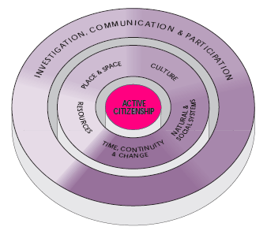

ACTIVE CITIZENSHIP
….Students demonstrate active citizenship through their behaviours and practices in the school environment, in accordance with the principles and values associated with the democratic process, social justice and ecological sustainability….

.…The behaviours and practices students display as active citizens reflect their commitment to the values and principles associated with the democratic process, social justice and ecological sustainability. This process of active citizenship is the basis for students to formulate, guide and critically review responsible social and environmental action….

.…Students critically analyse heritages and traditions of social justice and human rights, and policies and practices related to discrimination and disadvantage. Through this analysis they demonstrate behaviours consistent with the values associated with social justice, such as a respect and concern for the welfare, contribution, rights and dignity of all people; empathy with people of different belief systems and cultural groups; fairness and equity in dealing with people; and redressing disadvantage and changing discriminatory and violent practices….

In addition to SOSE; curriculum links may be drawn from the Health and Physical Education Learning Area, specifically in relation to attitudes and values.

ATTITUDES AND VALUES
2. Students exhibit attitudes and values that promote personal, family and community health, and participation in physical activity.

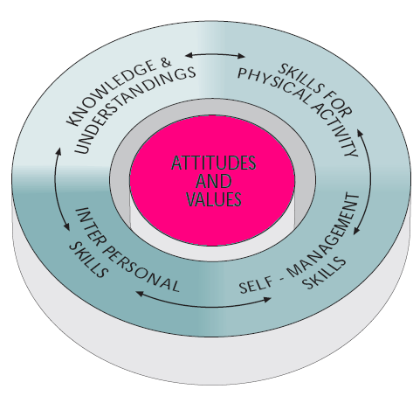
Students identify attitudes and values for a healthy active, lifestyle and demonstrate values consistent with the prevention of ill-health, the acceptance of personal responsibility for their health and physical activity levels, respect for social justice principles and a commitment to personal achievement. For some students, religious insights will feature significantly in values acquisition and implementation.

Students recognise and value, safe and supportive environments….. They demonstrate support for structures such as family, friendship groups, religious groups, support agencies and sporting teams…... They exhibit safe practice in the classroom, in play and in games, and observe occupational health and safety guidelines where appropriate……Students recognise and respect the principles of social justice. They demonstrate this by being inclusive and just in their interpersonal relationships in classroom, peer, friendship and team situations. They know and protect their own rights and respect the rights of others. In physical activity and sport, they recognise inequities and do not discriminate on the grounds of gender, race, culture, physical or mental disability or experiential background. Their actions reflect ethical considerations and a desire to rectify inequities that exist in school, social and sporting settings.

